#1 Internship Program Analysis

Data:


Trends on Department:

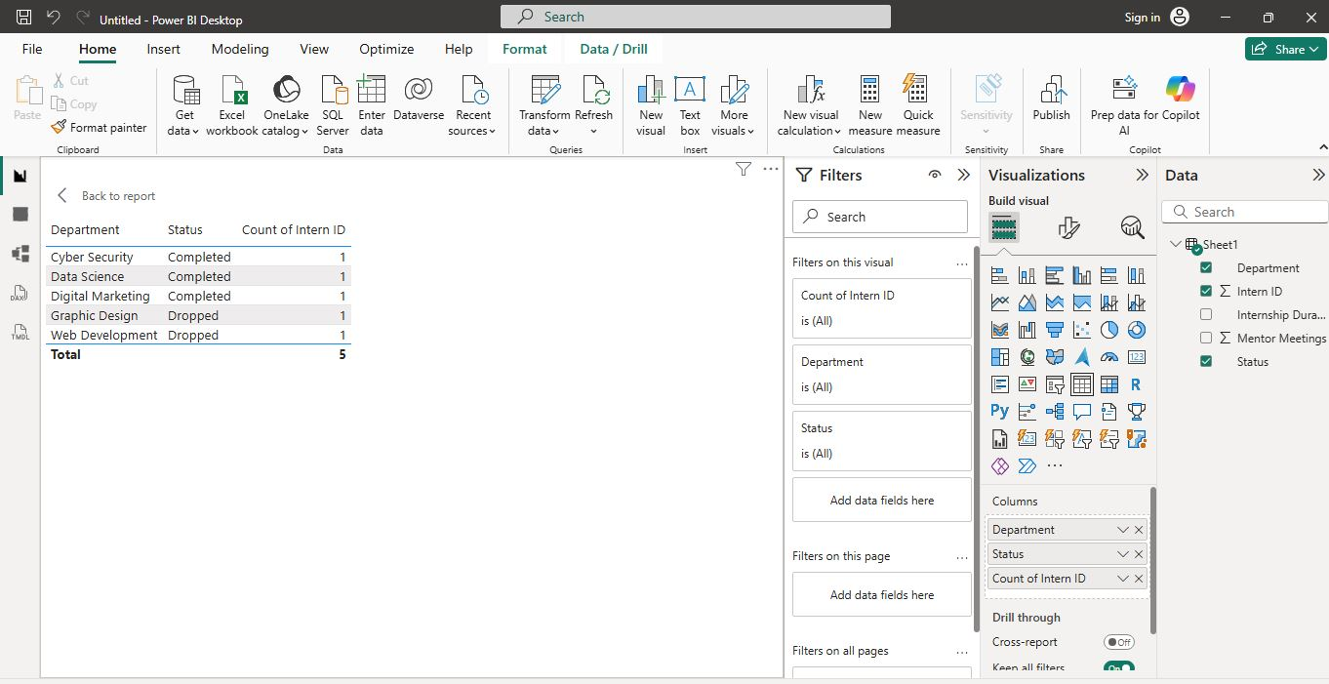
Data Science has the highest completion rate.

Trends on Duration:
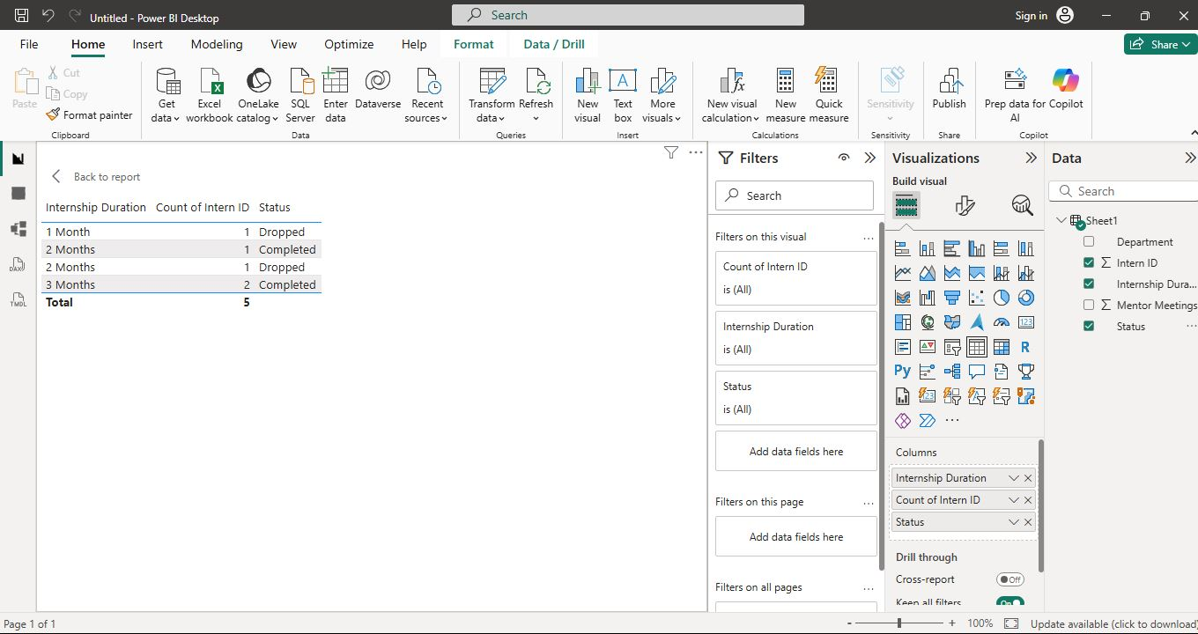
Three-month internships have the highest completion rate.
Trends on Mentor Interaction:
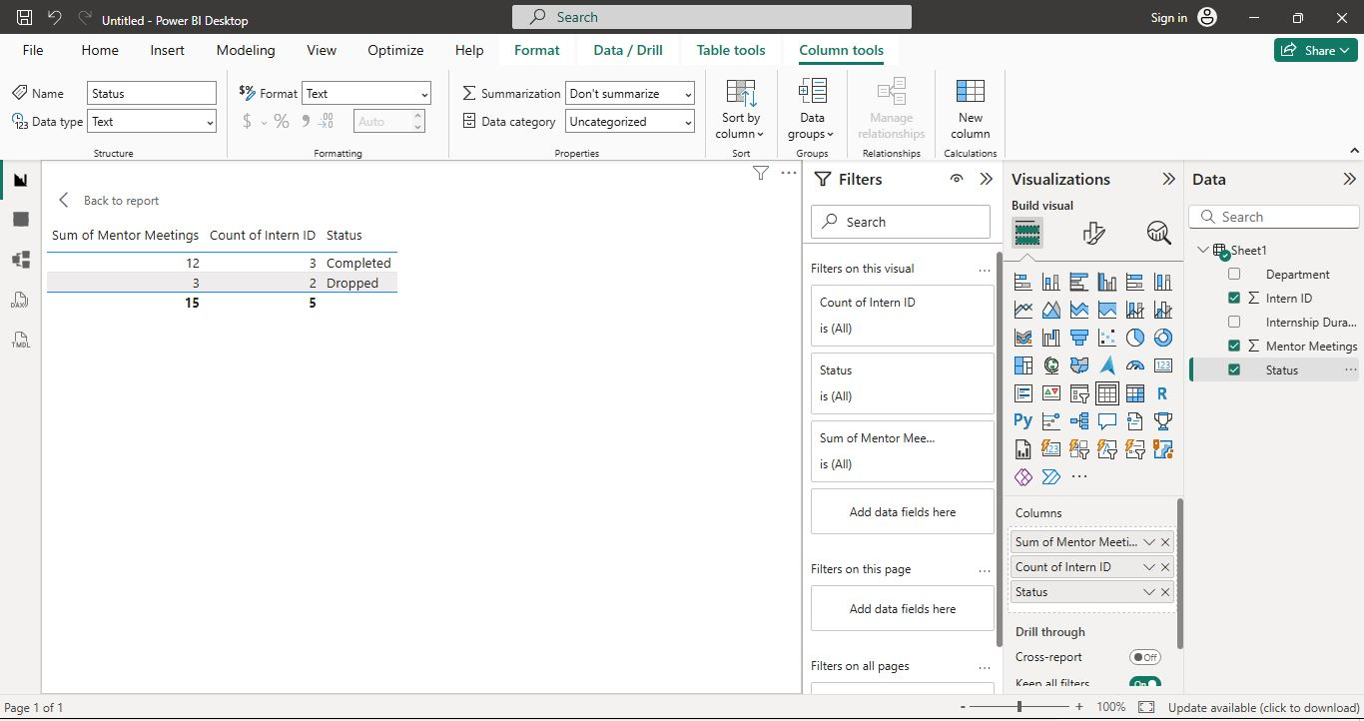
More mentor meetings are associated with higher completion.

Visualization on Department:
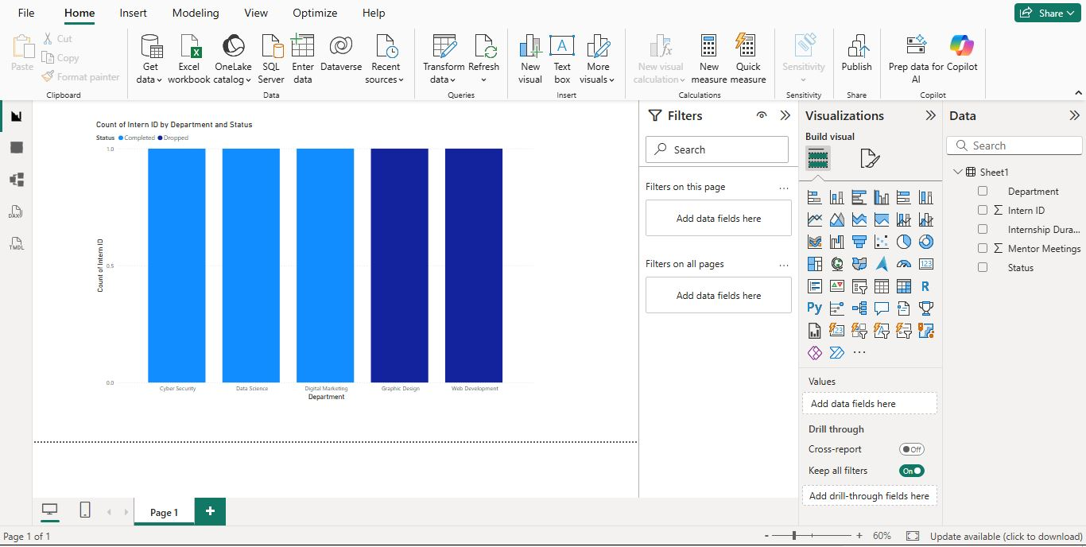

Visualization on Duration:

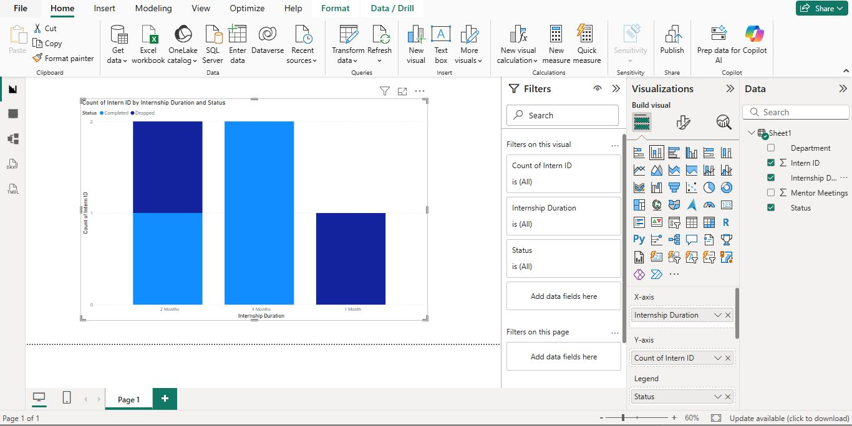
Visualization on Mentor:

